Ideation Phase Brainstorm & Idea Prioritization



Date

Team ID

Project Name

19 October 2022

PNT2022TMID54187

Fertilizers recommendation system for disease prediction

Maximum Marks

4 Marks

Brainstorm & Idea Prioritization

Step-1: Team Gathering, Collaboration and Select the Problem Statement

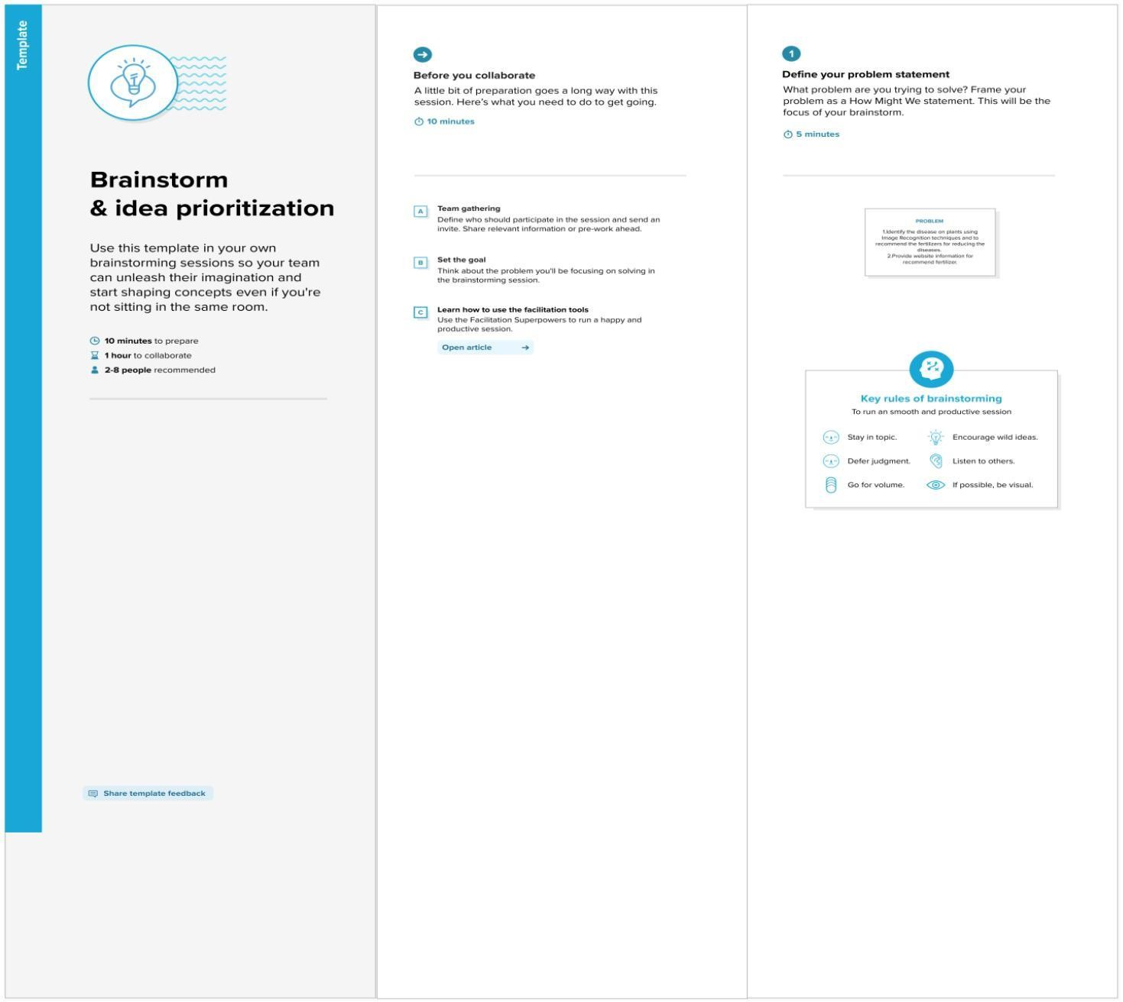

Step-2: Brainstorm, Idea Listing and Grouping

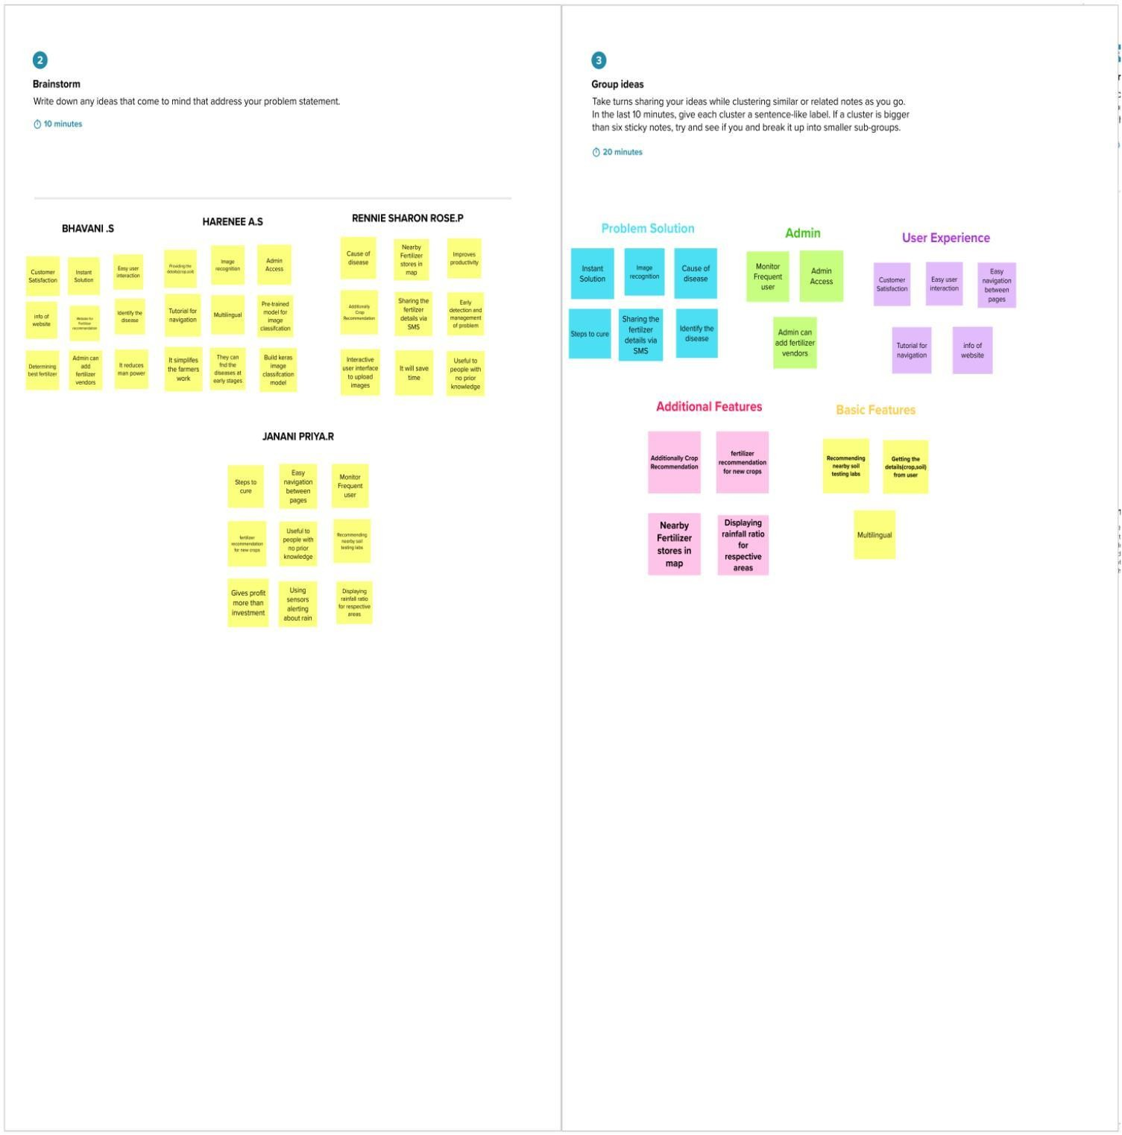

**PRANESH S**

**PARTHASARATHI S**

**SRIMATHI V**

**THAMARAISELVAN S P**

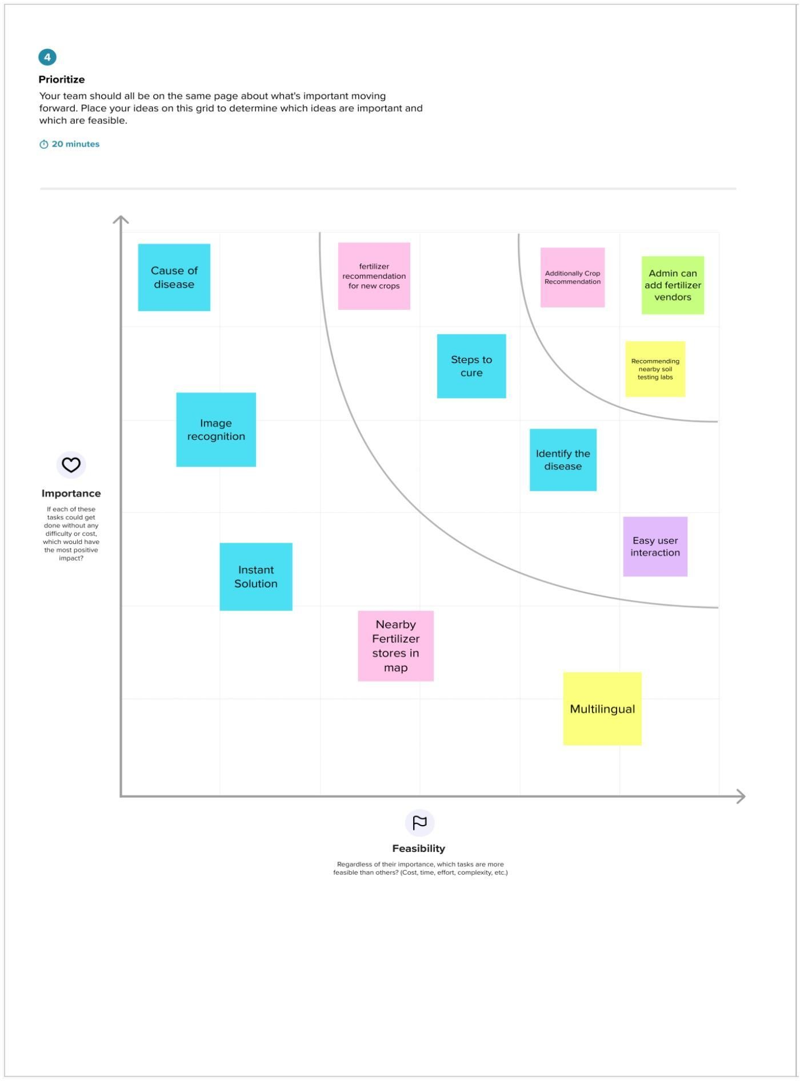Step-3: Idea Prioritization